**SEARCH ENGINE OPTIMISATION PROJECT**

**JILLIAN RYAN K00233554**

**Introduction:**

I used the layout of my News website and changed the content within it to Creative Multimedia content. I mainly used the content from the following LIT site <http://www.lit.ie/Courses/Springboard/7061.aspx.>

The URL for my site is: <https://k00233554.github.io/SEO/>

**Site Setup:**

I created an SEO folder and followed the usual steps of adding the img, css, js folders within the SEO project file. As I mentioned above, I used the layout of my News website and changed the content within the site. I then used the github instructions on Moodle to deploy the site. For some reason, the CSS would not carry over so I had to look into this further.

**Content Generation:**

Once the site was deployed, I started looking up various techniques on how to get my site to appear in a Google search. The site did not appear on Google search so I kept adding extra content into the site bit by bit. I added photos of LIT and added links to the LIT website, the LIT Instagram page, the LIT facebook page also. I included the names of all the modules on the course also and made sure I repeated the course name throughout all 4 pages on the site.

**Keyword Research & Targeting:**

I looked up various sites on SEO tips. I followed one in particular as it was easy to follow and was the first one that came up on the google search when I was searching for SEO tips. The name of the site is: https://goinswriter.com/website-seo-tips/

**SEO Actions and Results:**

One of the tips on this site was to update my site frequently so I changed a few things every few days on the site to keep it updated. I also ensured that the site was responsive as I was told that this would help with the ranking. I added a number into the header of the site as I read that people are more inclined to click on a site if they see that there are only a few steps to follow. The site, unfortunately, has not showed up on google as of yet, but I remain optimistic!!!I took the following steps also:

<https://goinswriter.com/website-seo-tips/> advised the following:

1. **“Make the website about one thing”** – this was easy as it we were tasked with making a site purely on the Higher Diploma in Creative Multimedia course.
2. “**Mention keywords where they matter most” and “Include your ‘one thing’ in the site title, domain name, description, tagline, keywords, blog categories, page titles, and page content.” -** I went through the html files and added keywords such as creative multimedia to the alt names, to the title, to the header and to the a hrefs.
3. “**Link to internal pages on your site**. **A lot of content management systems automatically do this, but if yours doesn’t, you’ll want to be intentional about linking to your most important pages directly from your homepage and cross-linking them with each other.” –** My site is very small and so I just used the navigation bar as a link between pages and also the links at the end of each page to link all the pages within the site also.
4. **“Use a permalink structure that includes keywords. Some sites have “ugly”**[**permalink**](https://en.wikipedia.org/wiki/Permalink)**structures that use numbers to identify pages. Don’t do this. It’s bad for SEO and just doesn’t look good. Use a URL structure that includes text, and make sure you include keywords in your URLs. So instead of having a page’s URL be this:** [***https://yoursite.com/?p=12***](https://yoursite.com/?p=12)

**It should look more like this:** [***https://yoursite.com/coolpage/***](https://yoursite.com/coolpage/)***” -***

My URL does not include any unusual characters. It does not include keywords either, which is unfortunate, but I did not want to change as it was too late to amend at this stage.

1. **“Remove anything that slows down your website.** [**Page load times**](https://googlewebmastercentral.blogspot.com/2010/04/using-site-speed-in-web-search-ranking.html)**are important, so get rid of any non-essentials that bog down your website. These may including music players, large images, flash graphics, and unnecessary plugins.”** – My site is very small and should not have issues loading. It does not include any music players or flash graphics. It does, however, have some big images, but I do not think these will cause a loading issue.
2. **“Use keywords in your images. Include words that reflect your site topic in the image title, description, and**[**alt attributes**](https://en.wikipedia.org/wiki/Alt_attribute)**. Also, re-title the file name if it doesn’t reflect your main keywords (e.g. *writing-tips.jpg* instead of *d1234.jpg*).”** – After reading this advice, I changed all the alt attributes to keywords eg creative multimedia.
3. **“Link to other websites with relevant content. You can do this by including a blogroll, link list, or**[**resources page**](https://goinswriter.com/resources)**on your website. Of course, do it sparingly, as each outbound link is a “vote” for another site. However, if you do it well and people click your links, this tells search engines you are a trusted authority on your particular topic.” -** After reading this advice, I added a link to LIT to the ads section at the bottom of website. I also added a link to the LIT website in the header as I read that this may help with boosting the site and making it appear on the google search list. As I mentioned at the beginning of this report, I also added links to the LIT Facebook and Instagram pages. I also added links to my fellow classmates’ SEO websites into my website.
4. **“Update your website frequently. Sites with dynamic content often rank higher than those with static content. That’s why blogs and directories (like Wikipedia) do so well on search engines. They are constantly being updated with new content.” –** I have updated the site numerous times with new content, images and links.
5. **“Make sure your website is indexed in search engines. A lot of search engines will automatically find and index your content, but don’t count on it. You want to be sure engines like Google, Bing, and Yahoo are crawling your site, so that people are finding you online. (You can add them directly, if they’re not.)” -**
6. **“Have other websites link to you. “ –**

I sent my URL to a few of my classmates and asked them to add them to their websites as a link. I did the same for them also.

1. “**Stop changing your domain name. The**[**age of your URL**](https://seoexample.co.uk/url-age)**is a factor in your site’s search ranking, so be patient. If you’re launching a new blog every six months, you’ll never see your site get the value it deserves.” –**

I kept the same domain name throughout.

1. **“Write like a human.” - “None of the above matters if you create content that sounds like a robot wrote it. Write great stuff, follow the steps above, have patience, and you’ll see results.” -** The content on my website is very easy to follow, it is not overly complicated and is easy to understand.

**Lessons learned:**

The main lesson I learned is that this does take time and it will not happen overnight. Although I did start this project a few weeks ago, I didn’t put a lot of time into updating it. After doing some research, I realised that I needed to be checking and updating the site as often as possible so as to see results. I had a few issues with CSS and images and so I should have asked for more help with this instead of trying to figure it out myself. The content is also very important and time and effort does need to be spent on what is included on this site so that it can rank higher, or, in my case, rank at all.

I also tried to use Google Analytics to verify the website but I kept getting the following error when I uploaded the HTML verification file to my SEO git hub account.

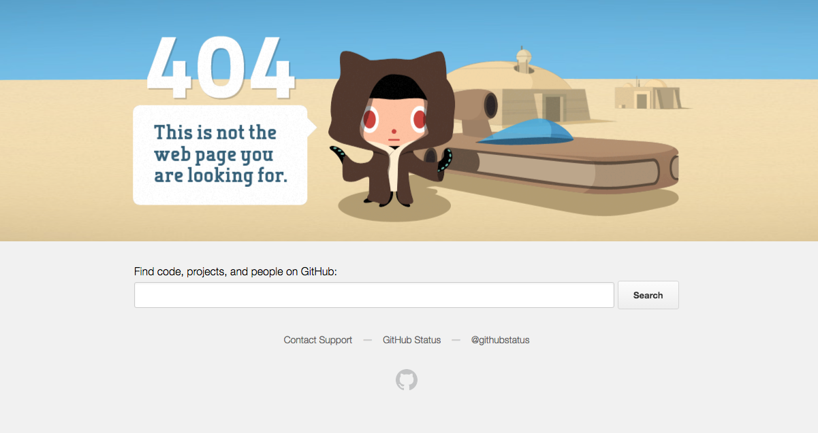

and:

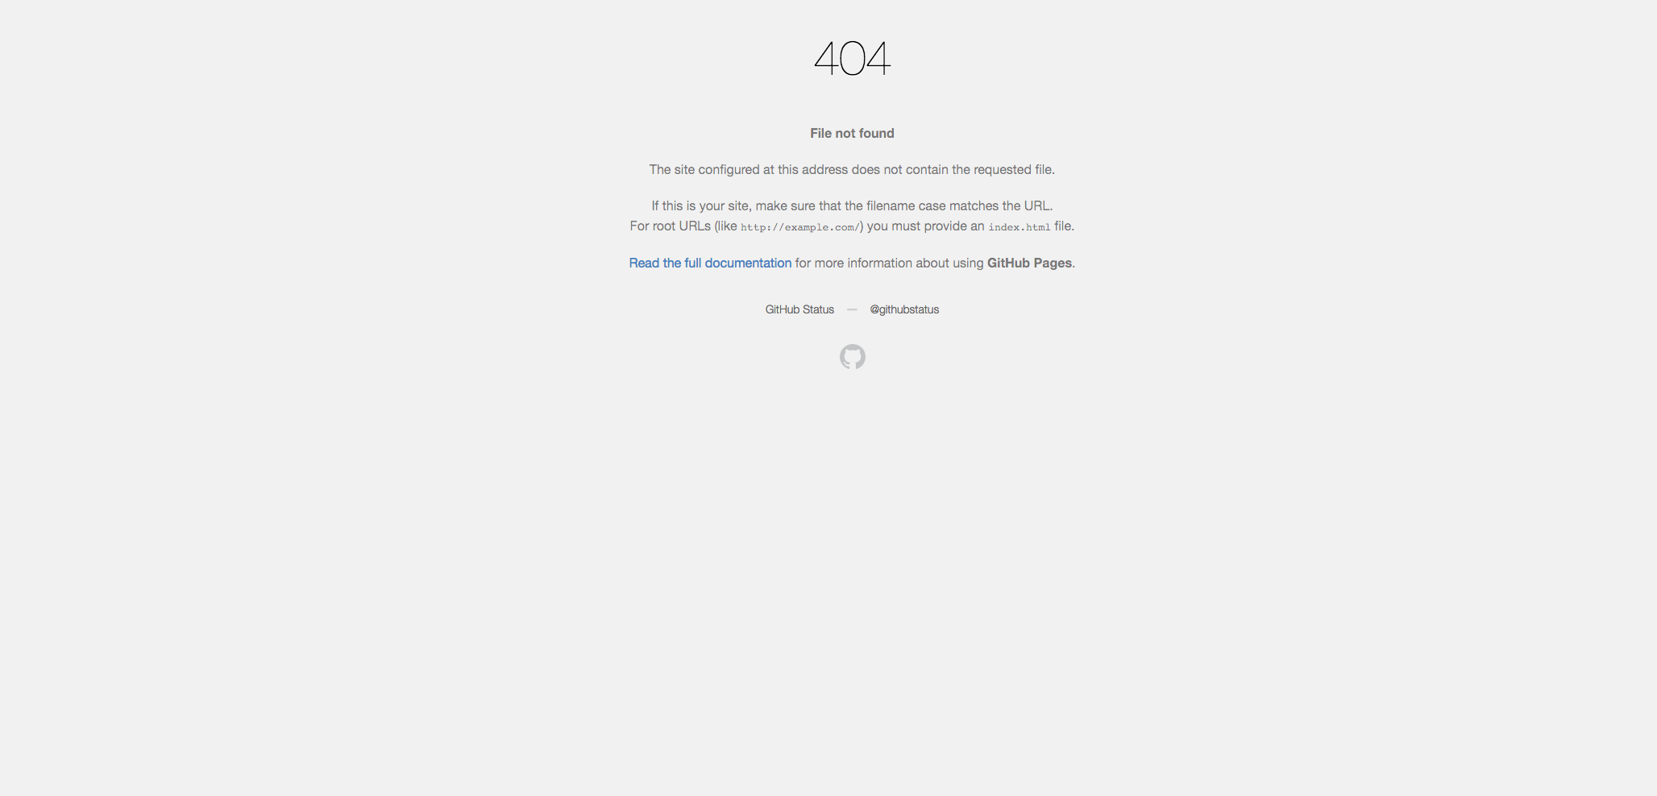

Again, this just proves that I needed to be updating and checking all these details along the way and not a week before the assignment was actually due. I tried to verify the ownership again by adding a meta tag to my home page however the below error appeared:

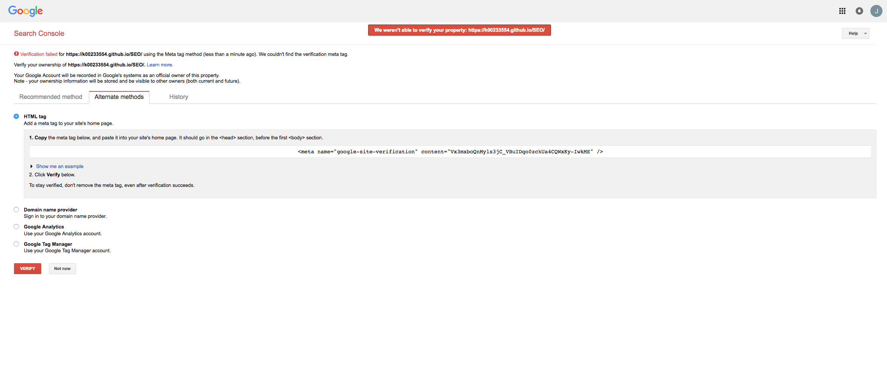

Eventually I succeeded in verifying my ownership of my SEO site.

I also had links to sponsors on my site but took them down as I obviously had no permission to add ‘Failte Ireland,’ for example, as a sponsor.

The main lesson I learned, as I said above, is that more original content needed to be added from the beginning, and I needed to update the site more often. Next time I will also ensure that my domain name includes key words instead of just my K00233554 details. I did not want to change this, however, as the age of the URL affects the ranking.